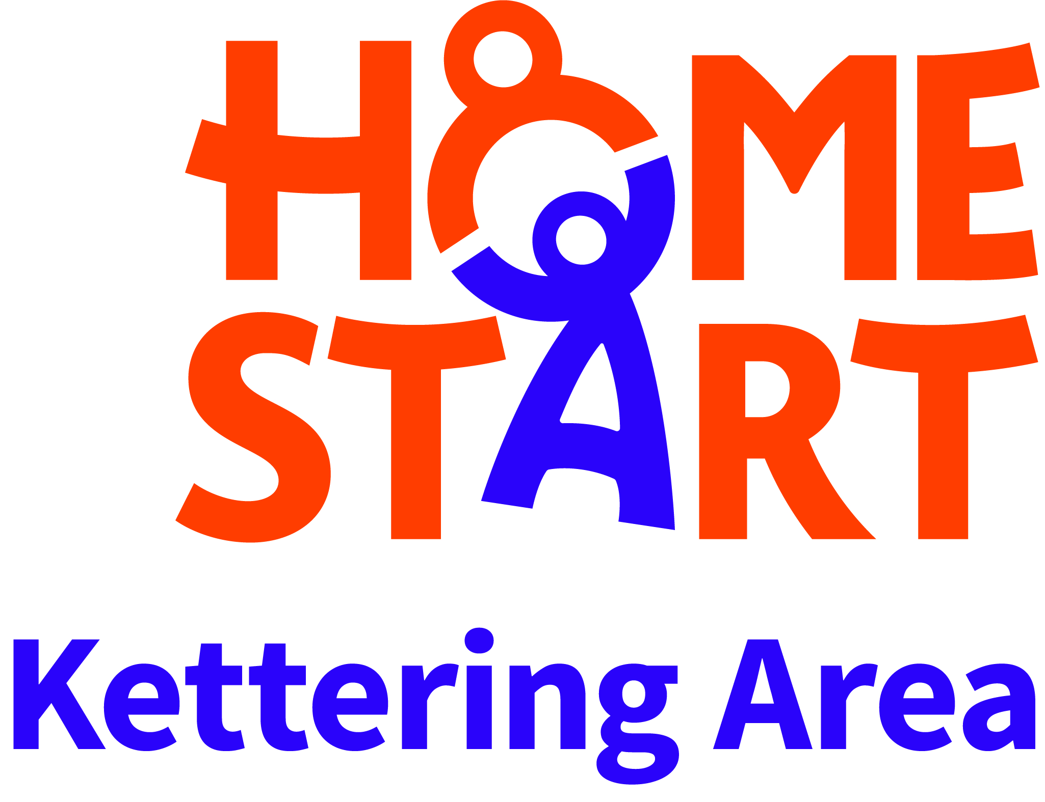
HOME-START KETTERING AREA
The Zone, William Knibb Centre, Kettering, Northants.
NN16 8AE

Registered Charity Number 1114030 Company Number 5709942

NAME: | Email Address:
ADDRESS:  POSTCODE: | At Current Address Since:
Tel: (Home) | Tel: (Mob)
Date of Birth: | Place of Birth:
Nationality: | Languages Spoken:
Are you employed: YES/NO? | If so for how many hours:

Ethnic Origin
White |  | Indian
Black Caribbean |  | Pakistani
Black African |  | Bangladeshi
 |  | Chinese
Black Other (Specify)
Other (Specify)

Which age group are you most interested in working with (please tick)
0-1yrs | 1-3yrs | 3-5yrs | 5-11yrs | Any

Availability (please tick all that apply)
Morning | Afternoon | Evening | Weekend | School Hols

Day availability (please tick all that apply)
Mon | Tues | Wed | Thurs | Fri | Sat | Sun

How did you hear about Home-Start?

What kind of work are you doing and/or have you done in the past?

How much time could you offer to Home-Start on a regular basis?

What type of transport would you use?

If a car, do you have a current clean driving license: YES / NO

Have you had any involvement with Home-Start before? YES / NO

If yes, please give details:

Please give details of any other voluntary work you are doing now, or have done in the past:

Have you any skills or personal experiences you feel may be relevant to Home-Start work? (eg Budgeting and money management, healthy eating, ASD, mental health, disabilities, addictions or domestic abuse).

Please say why you would like to become a Home-Start volunteer?

Is there any other information you would like to add?

HOME-START KETTERING AREA

As volunteers are in a privileged position visiting families in their own homes and have contact with young children, we have a responsibility to ensure that no one becomes a volunteer who would misuse this trust. When you start the course, you will be asked to provide details of:

Current Passport |  | Driving Licence
Any other legal document with photograph / signature
National Insurance Number
Please let us know if this causes any difficulties.

NAME:

Have you had any personal contact with Social Services/CYP or NSPCC in connection with children in your care? | YES / NO
Do you have any medical condition (physical or mental) that could affect your work as a volunteer? | YES / NO
Have you ever been dismissed from any paid or voluntary work? | YES / NO
Have you ever been convicted of any criminal offence? | YES / NO
Are there any matters outstanding which may lead to a criminal prosecution? | YES / NO
If you answer YES to any question, please give details overleaf. | YES / NO

REFERENCES: Please give the name and address of two referees (not a relative ) who may be contacted by Home-Start, someone you have known for at least two years.

1. |  |  | 2.

I give permission for the Manager of Home-Start Kettering Area to carry out a DBS check for criminal convictions, or any other checks with the Department of Health, Social Services or Department of Education. I know of no reason why I would be unsuitable to be a Home-Start volunteer.

SIGNED: DATED:

